**技术测试**

两道算法题目，：

有点像leetcode，第一个是字符串截取的，第二个是二叉树寻找两个子树节点数量的最大乘积。然后提交代码后，有十多个测试用例，跑完后告诉有多少不通过。不过，没有显示失败用例的输入和输出。

1. 给一堆整数，写算法，找出质数
2. A car travels from a starting position to a destination which is target miles east of the starting position.

There are gas stations along the way. The gas stations are represented as an array stations where stations[i] = [position_i, fuel_i] indicates that the ith gas station is position i miles east of the starting position and has fuel_i liters of gas.

The car starts with an infinite tank of gas, which initially has start Fuel liters of fuel in it. It uses one liter of gas per one mile that it drives. When the car reaches a gas station, it may stop and refuel, transferring all the gas from the station into the car.

Return the minimum number of refueling stops the car must make in order to reach its destination. If it cannot reach the destination, return -1.xx

1. 有一个二维表，里面有数字0 1 9，0代表墙，1代表路，9是终点，有一个人从某个坐标开始移动，判断他是否能到达终点

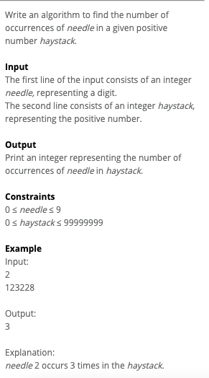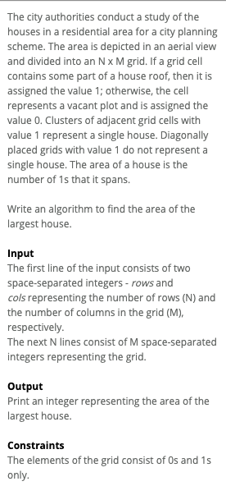

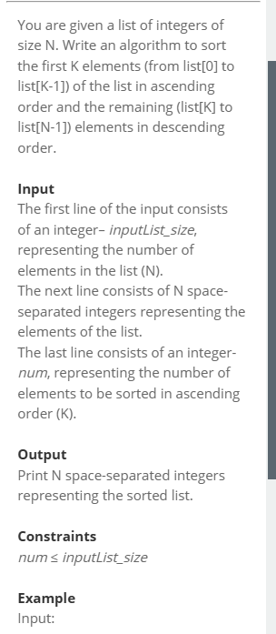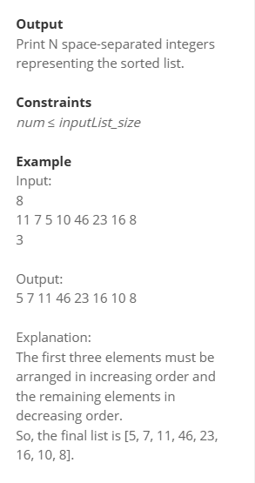

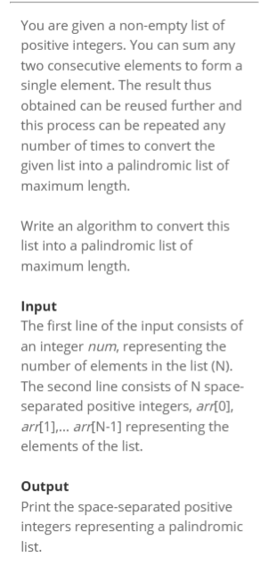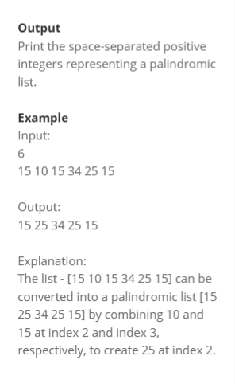

1. 题目描述了一种叫做“最短作业优先”（Shortest Job First, SJF）的任务调度系统。在这个系统中，每个任务请求都有两个特点：一个是请求时间（也就是任务提交给系统的时间），另一个是任务的持续时间（完成任务所需要的时间）。

当SJF系统完成一个任务时，它会选择下一个要执行的任务。被选中的任务是所有当前等待的任务中持续时间最短的那个。如果有多个任务的持续时间相同，那么系统会选择请求时间最早的那个任务。

任务的等待时间是任务的请求时间与它实际开始执行的时间之间的差值。题目要求计算使用SJF调度算法时，任务的平均等待时间。输入：

第一行包含一个正整数，表示任务的数量。

第二行包含多个整数，表示每个任务的请求时间。

第三行也包含一个正整数，再次确认任务的数量。

第四行包含多个整数，表示每个任务的持续时间。输出：

输出一个实数，表示使用非抢占式SJF调度算法计算出的任务平均等待时间，结果保留两位小数。

约束条件：

任务的请求时间和持续时间都是按照请求时间的升序排序的。

0 ≤ 请求时间<1000

0 < 持续时间 < 100

0≤请求时间<1000,0<持续时间<100

题目描述了一个模拟问题，关于一排房屋（或单元格）如何随时间变化。每个房屋在一天结束时都会根据它的邻居的状态来改变自己的状态。题目的具体要求如下：

有八个房屋，排成一直线。

每个房屋都有一个状态，1 代表活跃，0 代表非活跃。

每天每个房屋都会与它的邻居竞争。如果两个邻居的状态相同（都是 1 或都是 0），那么这个房屋第二天就会变成非活跃状态（0）。如果两个邻居的状态不同，那么这个房屋第二天就会变成活跃状态（1）。

第一和最后的房屋只有一个邻居，可以假设另一个邻居的状态总是 0。

题目要求编写一个算法，输入当前每个房屋的状态和经过的天数，输出给定天数后每个房屋的状态。

输入：第一行是房屋的数量（总是 8）。

第二行包含 8 个空格分隔的整数，表示每个房屋当前的状态（1 或 0）。

第三行是经过的天数。输出：

输出 8 个空格分隔的整数，表示给定天数后每个房屋的状态。

示例：

输入：

8

1 0 0 0 0 1 0 0

1输出：

0 1 0 0 1 0 1 0

解释：

第一个房屋的状态是 1，它的邻居的状态是 0，所以它第二天的状态是 0。

第二个房屋的状态是 0，它的邻居的状态是 1 和 0，所以它第二天的状态是 1。

以此类推，所有房屋第二天的状态是 0 1 0 0 1 0 1 0。

1. 统计两个数组非公共元素个数
2. 给定容量lru缓存的cache miss数
3. 计算两个数组的非公共元素个数
4. 给定一个数组，取大小相等的两个子数组，第二个子数组倒置，两个子数组对应位置相乘并对结果累加，问能得到的最大值是多少（该题目原题会比较绕，需要仔细理解才能捋清楚题目的要求）
5. 2个字符串，a和b，求字符串b在a中出现的次数。
6. 从一系列 string中，找到他们从第一个字母起的最长的公共子串。输入2行第一行 数字N， ? > N >= 0第二行 N个字符串 例如：4molly molion molern mold输出mol要实现的方法String solution(int N, String[] strings){}
7. 给定4 个数 a, b, c, d ，表示分子的重量（？记不清概念了），要用来合成一种复合分子。复合分子的重量，由组成的分子重量之和，但是 c , d需要先乘以2. 输入这4个数和一个复合分子的重量，求可以最多可以用多少个分子组合成复合分子。 例如a = 5, b = 6,c = 2, d = 4X = 21那么所用分子最多的组合可以是：c * 2 = 4, 21 % 4 = 15 个 c， 无法组成4 个 c，加1个a，（c * 2 * 4 + a ) = X所以答案是 5.
8. 给数组按照数字的频率排序
9. 在一棵树中找到一条边，使得其两侧节点数的乘积最大
10. 找字符串子串出现的次数
11. 按照规则统计分数

（1）

The current selected programming language is Java. We emphasize the submission of a fully working code over partially correct but efficient code. Once submitted, you cannot review this problem again. You can use System.out.println() to debug your code. The System.out.println() may not work in case of syntax/runtime error. The version of JDK being used is 1.8.

Note: The main class name must be "Solution".

Mary, a physical education teacher, divides her students into different groups and assigns an ID to each group. For the group ID, she asks the students to stand in a queue. Each student in the class has a performance factor (PFR). She assigns scores to the students in an unusual way based on their PFR. She gives a score of 5 to a student behind whom is standing at least one student with a higher PFR, behind whom is standing at least one student with a smaller PFR. Next, she gives a score of 10 to a student behind whom is standing a student with a higher PFR, behind whom no student with smaller PFR is standing. Finally, she gives a score of 15 to a student behind whom is standing no student with a higher PFR. The group ID is the sum of scores of the students in the group.

Write an algorithm to find the group ID of a group of students.

Input The first line of the input consists of an integer num, representing the number of students in a group. The second line consists of N space-separated integers - listPFR[0], listPFR[1],......,listPFR[N-1] representing the PFR of the students in the order in which they are standing in the queue.

Output Print an integer representing the group ID of the group of students.

Constraints 1 ≤ num ≤ 10^5 -10^9 ≤ listPFR[0], listPFR[1],......,listPFR[N-1] ≤ 10^9

Example Input: 6 1 4 5 2 7 8

Output: 55

Explanation: The student with a PFR 1 has a student with a PFR 4 next to him/her, and a student with a PFR 2 is standing behind the higher PFR student. So, Mary gives a score of 5 to the first student. Similarly, a score of 5 has been granted to the student with the PFR 4. The student with a PFR 5 has a student with a PFR 7 standing behind him/her and there is no student with a smaller PFR standing behind that higher PFR student. So, Mary gives a score of 10 to the student with PFR 5. Similarly, she gives a score of 10 to the students with the PFR 2 and 7. The student with a PFR 8 does not have any higher PFR student behind him/her. So, Mary assigns this student a score of 15. Thus, the group ID = 55(5+5+10+10+10+15). So, the output is 55.

（2）

Question

The current selected programming language is java. We emphasize the submission of a fully working code over partially correct but efficient code. Once submitted, you cannot resubmit this problem again. You can use System.out.println() to debug your code. The System.out.println() may not work in case of syntax/runtime error. The version of JDK being used is 1.8.

Note: The main class name must be "Solution".

Ethan is the leader of a team with N members. He has assigned an error score to each member in his team based on the bugs that he has found in that particular team member’s task. Because the error score has increased to a significantly large value, he wants to give all the team members a chance to improve their error scores, thereby improving their reputation in the organization. He introduces a new rule that whenever a team member completes a project successfully, the error score of that member decreases by a count P and the error score of all the other team members whose score is greater than zero decreases by a count Q.

Write an algorithm to help Ethan find the minimum number of projects that the team must complete in order to make the error score of all the team members zero.

Input

The first line of the input consists of an integer- errorScore_size, representing the total number of team members (N).

The second line consists of N space-separated integers- errorScore, representing the initial error scores of the team members.

The third line consists of an integer- compP, representing the count by which the error score of the team member who completes a project successfully decreases (P).

The last line consists of an integer- othQ, representing the count by which the error score of the team member whose error score is greater than zero decreases (Q).

Output

Print an integer representing the minimum number of projects that the team must complete in order to make the error score of all the team members zero. If no project need to be completed then print 0.

Constraints

1 ≤ errorScore_size ≤ 2*10^5

1 ≤ othQ ≤ compP ≤ 10^9

0 ≤ errorScore ≤ 10^9

Note

The error score of any team member can never be less than zero.

Example

Input:

3

6 4 1

2

1

Output:

3

Question

The current selected programming language is java. We emphasize the submission of a fully working code over partially correct but efficient code. Once submitted, you cannot review this problem again. You can use System.out.println()to debug your code. The System.out.println() may not work in case of syntax/runtime error. The version of JDK being used is 1.8.

Note: The main class name must be "Solution".

A prime number is divisible only by 1 and itself.

The teacher writes a positive integer on the board. Write an algorithm to find all the prime numbers from 2 to the given positive number.

Input

The first line of the input consists of an integer num, representing the number written on the board.

Output

Print space-separated integers representing the prime numbers requested by the teacher in increasing order. If no prime number exists within given range, then do not print anything.

Constraints

1 < num < 10^9

Example

Input:

11

Output:

2 3 5 7 11

Explanation:

For the given number, the prime numbers are 2, 3, 5, 7, and 11.

### Question

amount of oil that can be transported via the network at any given time.

### Constraints

* 3≤num≤1053≤*num*≤105
* 1≤baseR≤1051≤*baseR*≤105
* 1≤rate≤1031≤*rate*≤103
* numCon = num - 1
* charCon = 3

### Example

Input:

深色版本

64

5 3

4 2 10

4 6 20

4 1 30

1 3 50

1 5 80

Output:

深色版本

60

### Explanation:

Oil is transported in the network as shown below:

* From pipe (4) -> (2): 10 units of oil is transported.
* From pipe (4) -> (6): 20 units of oil is transported.
* From pipes (4) -> (1) -> (3) & (4) -> (1) -> (5): only 30 units of oil can be transported, as the (4)-(1) pipe can transfer only 30 units of oil.
* So, the maximum optimal flow through the network is 60(10+20+30).

### Question

The current selected programming language is C#. We emphasize the submission of a fully working code over partially correct but efficient code. Use of certain header files are restricted. Once submitted, you cannot review this problem again. You can use System.Console.Write()to debug your code. The version of C# being used is 6.12

A colony of eight houses, represented as cells, are arranged in a straight line. Each day every cell competes with its adjacent cells (neighbours). An integer value of 1 represents an active cell and value of 0 represents an inactive cell. If both the neighbours are either active or inactive, the cell becomes inactive the next day; otherwise it becomes active on the next day. The two cells on the ends have a single adjacent cell, so the other adjacent cell can be assumed to be always inactive. Even after updating the cell state, its previous state is considered for updating the state of other cells. The cell information of all cells should be updated simultaneously.

Write an algorithm to output the state of the cells after the given number of days.

Input

The first line of the input consists of an integer num representing the number of cells (where num is always equal to eight).

The second line consists of eight space-separated integers - cell1, cell2,................ cell8 representing the current state of cells.

The third line consists of an integer days, representing the number of days.

Output

Print eight space-separated integers representing the state of the cells after the given number of days.

Note

The state of the cells is represented by 0s and 1s only

Example

Input:

8

### Question

The current selected programming language is C#. We emphasize the submission of a fully working code over partially correct but efficient code. Use of certain header files are restricted. Once submitted, you cannot review this problem again. You can use System.Console.Write()to debug your code. The version of C# being used is 6.12

A colony of eight houses, represented as cells, are arranged in a straight line. Each day every cell competes with its adjacent cells (neighbours). An integer value of 1 represents an active cell and value of 0 represents an inactive cell. If both the neighbours are either active or inactive, the cell becomes inactive the next day; otherwise it becomes active on the next day. The two cells on the ends have a single adjacent cell, so the other adjacent cell can be assumed to be always inactive. Even after updating the cell state, its previous state is considered for updating the state of other cells. The cell information of all cells should be updated simultaneously.

Write an algorithm to output the state of the cells after the given number of days.

Input

The first line of the input consists of an integer num representing the number of cells (where num is always equal to eight).

The second line consists of eight space-separated integers - cell1, cell2,................ cell8 representing the current state of cells.

The third line consists of an integer days, representing the number of days.

Output

Print eight space-separated integers representing the state of the cells after the given number of days.

Note

The state of the cells is represented by 0s and 1s only

Example

Input:

8

### Question

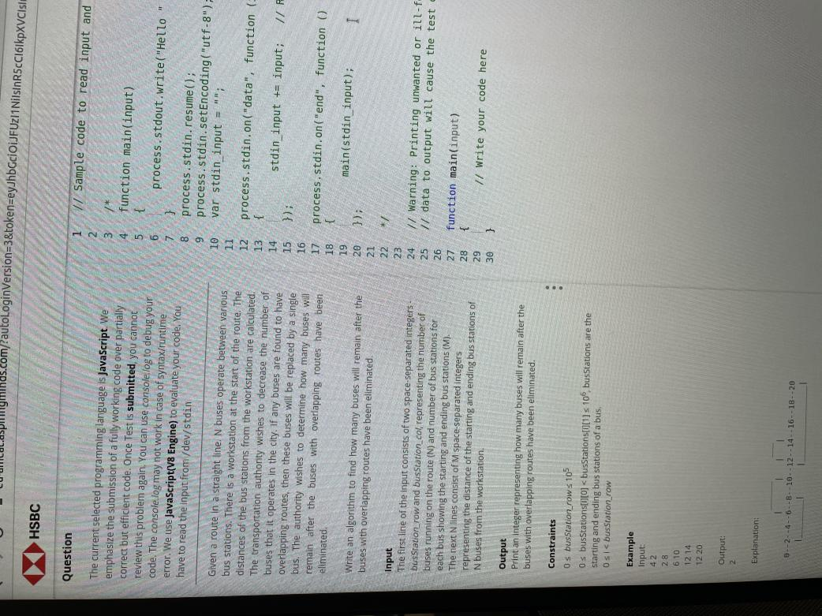

### Question

The current selected programming language is Java. We emphasize the submission of a fully working code over partially correct but efficient code. Once submitted, you cannot review this problem again. You can use System.out.println() to debug your code. The System.out.println() may not work in case of syntax/runtime error. The version of JDK being used is 1.8.

**Note:** The main class name must be "Solution".

You are given two strings containing only English letters. Write an algorithm to count the number of occurrences of the second string in the first string. (You may disregard the case of the letters.)

### Input

The first line of the input consists of a string parent, representing the first string. The second line consists of a string sub, representing the second string.

### Output

Print an integer representing the number of occurrences of Sub in Parent. If no occurrence of Sub is found in Parent then print 0.

### Example

Input:

深色版本

TimisplayinginthehouseofTimwiththetoysofTinTim

Output:

深色版本

3

Explanation: Tim occurs 3 times in the first string. So, the output is 3.

### Question

Tim, a seventh grade student, is introduced to the concept of lines in basic geometry class. He applies this concept in real life. If he considers his house as one point and his friend Bill's house as another point, he can draw a line between these two points. Similarly, if the houses of all his friends are considered as different points, he can draw multiple lines with his own house as the common point in each line. By taking his school as the reference, Tim marks the coordinates of his N friends' houses.

Write an algorithm to help Tim that takes the coordinates of his house (x0, y0) and his friends' houses (xi, yi) and outputs the number of unique lines that can be drawn with Tim's house as the common point in each line.

Input The first line of the input consists of two space-separated integers - num and numCoordinates representing

### Question

The current selected programming language is Python. We emphasize the submission of a fully working code over partially correct but efficient code. Once submitted, you cannot review this problem again. You can use print to debug your code. The print may not work in case of syntax/runtime error. The version of Python being used is 3.4.3.

Mitchell has invented a machine that outputs the most frequently occurring characters in a string that lie in the range [L, R]. The machine accepts a series of characters and asks the user to input two numbers, L and R. The machine outputs the characters for all the pairs of [L, R] values the user provides.

Write an algorithm to help Mitchell find the output for all the inputs he provides.

Input The first line of the input consists of a string strS, representing the series of characters that are fed to the machine initially. The second line consists of two space-separated integers - numPair and valPair, representing the number of pairs provided by the user (P) and number of values in each pair (N=2 always), respectively. The next P lines consist of N space-separated integers - valL and valR, representing the values of the lower and upper range for the pairs [L, R], respectively.

### Input

The first line of the input consists of two space-separated integers - num and numCoordinate, represent the number of Tim's friends (N), number of coordinates in each of the house position (M is always equal to 2), respectively.  
The next N lines consist of two space-separated integers - frndXi and frndYi representing the X-coordinates and the Y-coordinates of the houses of Tim's friends.  
The next line consists of an integer - timX0, representing the X-coordinate of Tim's house.  
The last line consists of an integer - timY0, representing the Y-coordinate of Tim's house.

### Output

Print an integer representing the minimum number of lines that can be drawn.

### Constraints

* 1≤num≤1051≤*num*≤105
* −1000≤frndXi,frndYi,timX0,timY0≤1000−1000≤*frndXi*,*frndYi*,*timX*0,*timY*0≤1000

